Home Work 4: Oracle SQL Class

# Research

In your own words give a brief definition of CRUD as it relates to databases.

The **CRUD** acronym is a mnemonic for Create, Retrieve, Update and Delete – four primary functions enabled in databases. The SQL commands for these operations are CREATE/INSERT, SELECT, UPDATE and DELETE.

In your own words give a brief definition of ACID as it relates to databases.

**ACID is a conceptual model of database management that sets goals of Atomicity,** Consistency, Isolation and Durability as requirements for reliability. ACID principles remove ambiguity from states and transactions.

In your own words give a brief definition of Atomicity as it relates to databases.

**Atomicity** requires database modifications and transactions to be “all or nothing”. That means if any part of the transaction fails, the entire transaction fails. Atomicity holds even in the event of DBMS or hardware failure.

In your own words give a brief definition of Drilling Down as it relates to databases.

**Drilling Down** is moving deeper into a chain of data – from high-level information to more detailed, focused information. Moving downward through a data hierarchy.

In your own words give a brief definition of Granularity as it relates to databases.

**G*ranularity***of data refers to the fineness to which data fields are sub-divided. When data is broken down to a low level (e.g. street number, street name, suite, city, state, zip) it is highly granular. High granularity increases flexibility but can negatively affect performance.

# DECODE

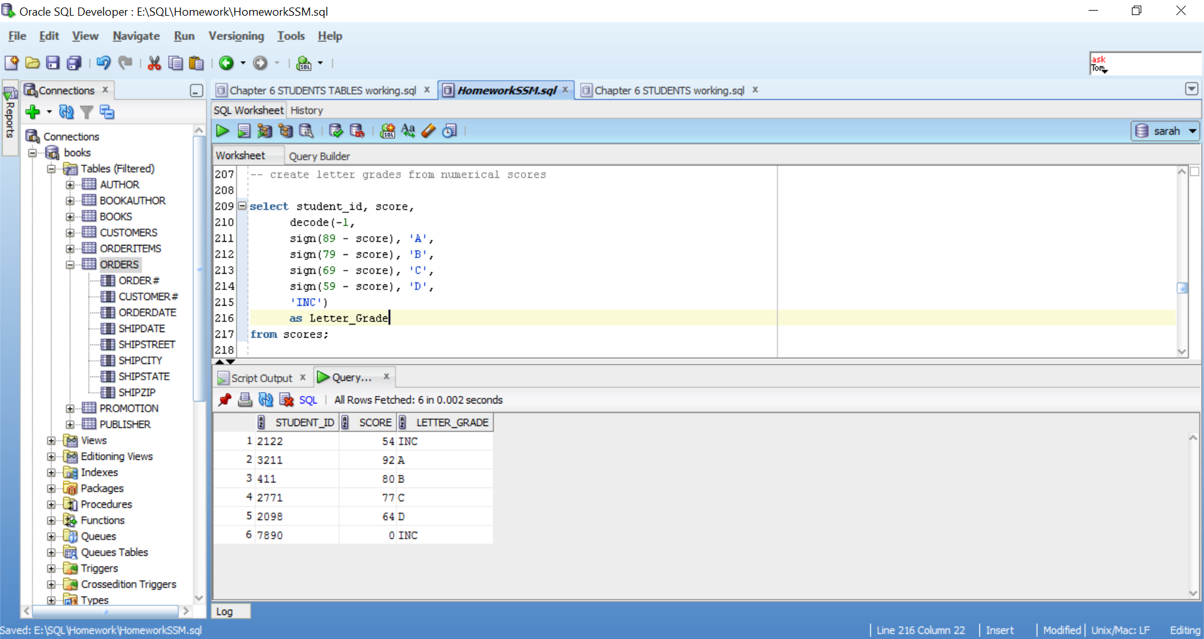

# Transform null

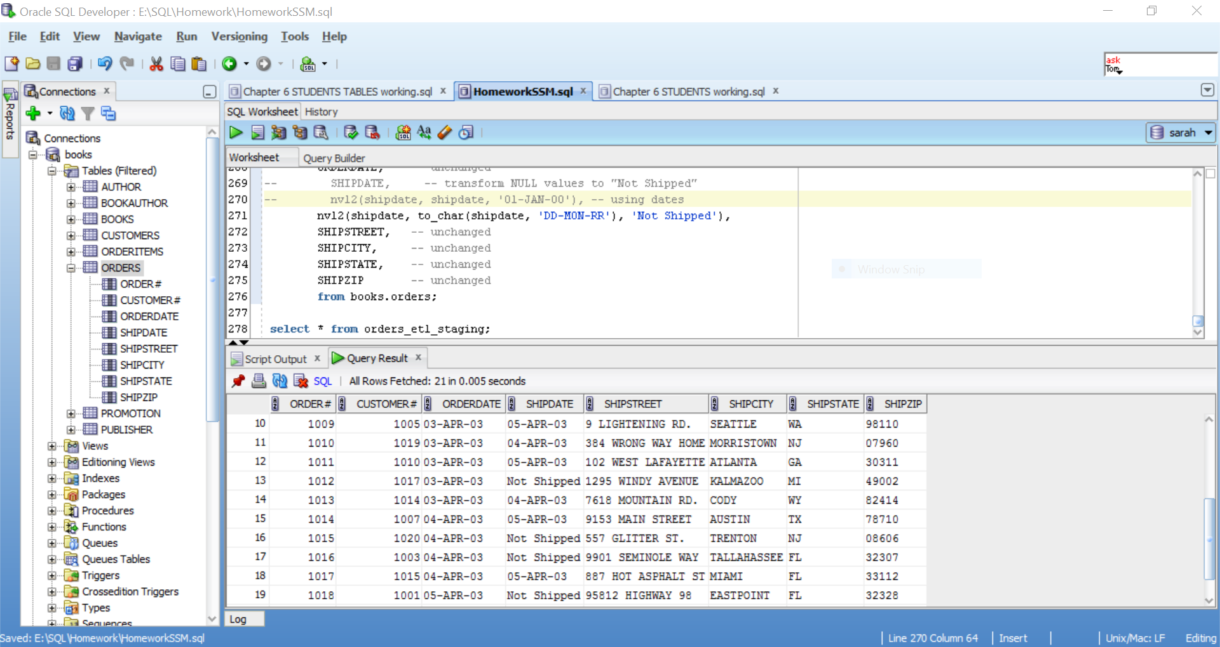

# Transform date, number

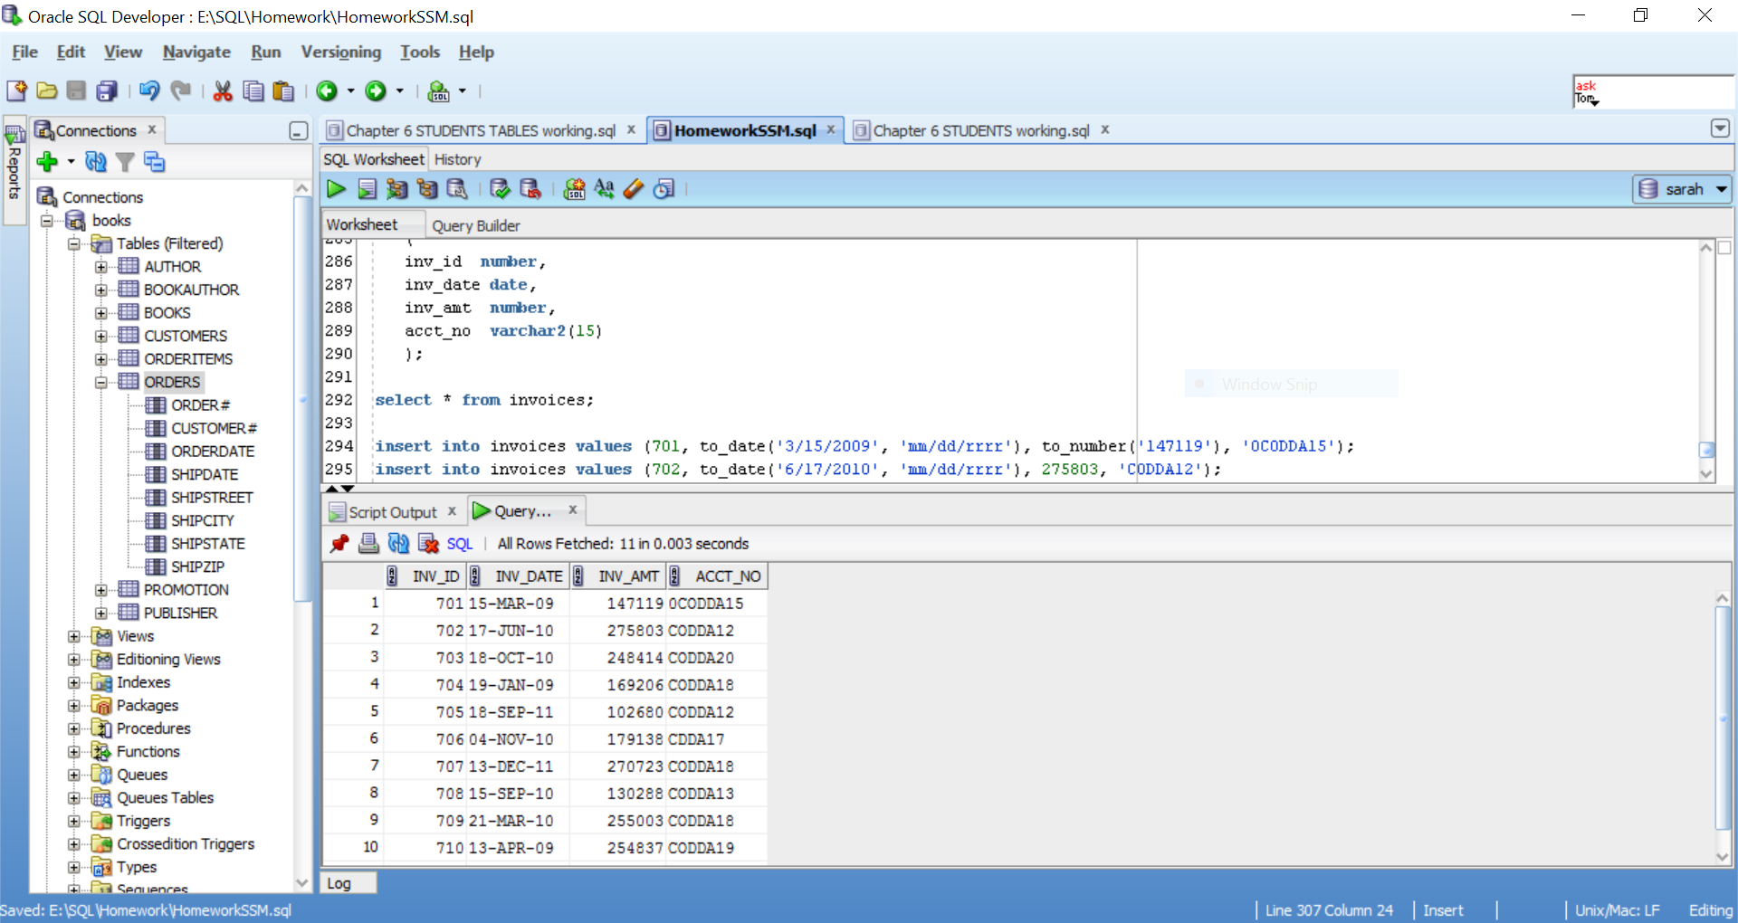

# Case Statement

